WiRE-FRAME

FLIGHT FARE ESTIMATOR

Table of Contents

1.HOME PAGE 3

1.1 What is “Enter absolute path.”? 3

1.2 What is Input File Predict? 3

1.3 What is Results Section? 4

# 1.HOME PAGE

We have created home page section in such a way that user will feel very easy to interact with our product. Here is how our home page is 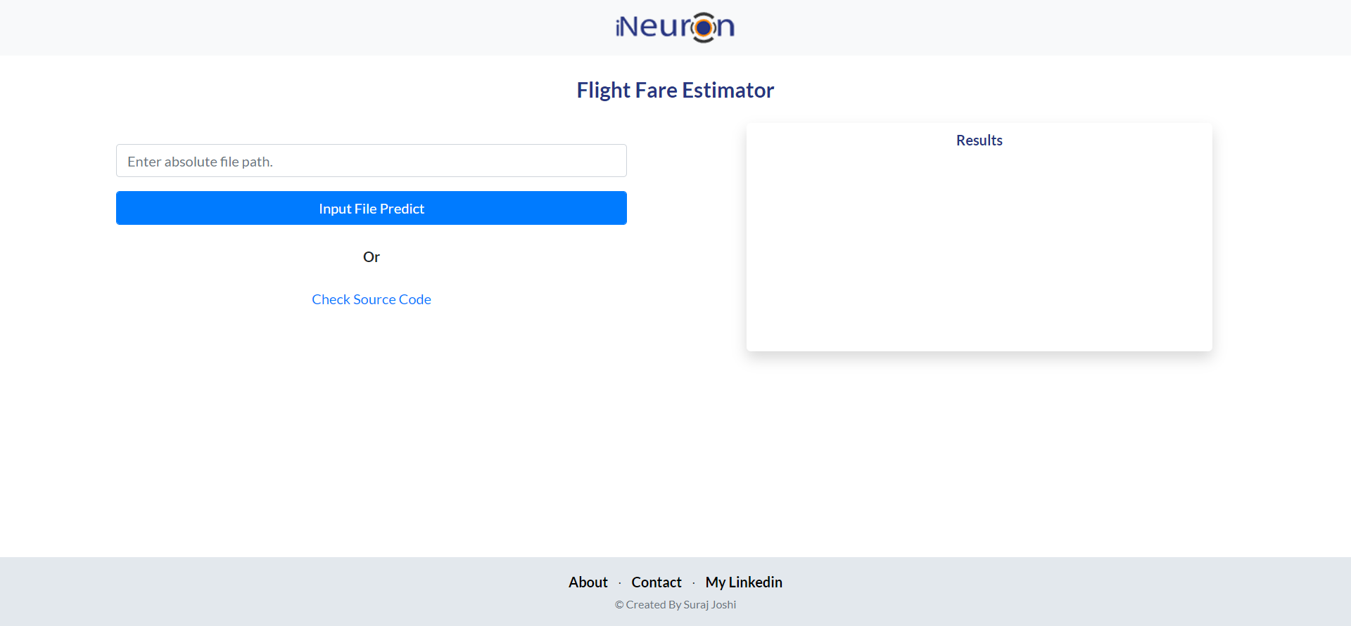

## What is “Enter absolute path.”?

Ans) In this place You have to paste the location of the folder in which the files are present.

For example folder name is Raw_Data and it is placed in D drive and then the path will be

D:\Raw_Data.

## What is Input File Predict?

Ans) Suppose you have pasted the path inside the section ‘Enter absolute path’. Now when you will hit button Input File Predict . The path file will go from html page to our main.py file and after that .csv files present inside it will be validated and prediction will be done.

## 1.3 What is Results Section?

Ans) This section will show the name of the folder created and few results of the predicted data. If incase something exception happens inside the system it will throw error occurred statement. Now you have to check the logs file In folder All_logs, There are two logging file one is Training_logs and second is Testing_logs. Logs generated during training is inside training logs and during prediction time it is insde testing_logs.

**NOTE:**

**It will simply create a folder names Output_Files in your path specified and in that the output files we stored and with that log file will also be generated.**